iRemote Platform Open Proposal

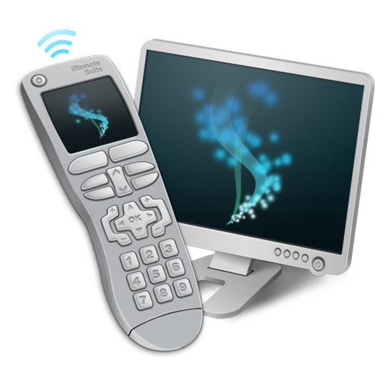

Owner: | Egor Pushkin
Version: | 1.02 as of 09/15/2012
Access: | Public

Abstract
This document represents proposal for potential iRemote partners (contributors and sponsors). Brief introduction into iRemote project is given, so no preliminary acquaintance is required. The document describes current project status and roadmap. Areas of solution adoption and business model are also briefly touched here. Most features, described below, are still in review and are subject to be extended or removed as the project moves forward. This document is intended to shape project outline and to show its potential and perspectives.

Introduction
What can you see in every second hand in ten years? There is the only correct answer – smartphone. No matter how this word is defined. This is something everyone can use for communication, work, data exchange, games and etc. What is this list missing? You will never be able to keep all data and required performance resources in your hand. Major tendency is to move these things even abroad desktops towards server side clouds. Returning back to relatively slow and limited in hardware capabilities mobile devices, it makes sense to notice that there is no need in porting most software for these platforms. There is no even need to develop clients (neither thin nor thick) for such software. From the huge variety of such applications I would like to pick out the following examples: modeling and simulation software, 3d rendering software, mathematics packages, application servers, etc. From the first point of view there are just a couple of common operations to perform remotely on such kind of software: observing status of any long task, confirmation of any operation or slight configuration update.
In practice, everyone faces with such situations on daily basis. This concerns not only network administrators, enterprise monitors and system analysts. This concerns everyone. The only stopping factor is that with huge amount of remote control protocols there is no common, simple, convenient and widespread way to achieve this.
iRemote platform comes here.

Definitions
iRemote Suite is software for mobile device allowing users to rich desktop workstation, laptop or server and be able to interact with it remotely.
Remote PC Suite is software for desktop, laptop or server, which is responsible for connection handling and simulation of various kinds of user input as well as delivery of data back to mobile device.
iRemote Protocol describes the way iRemote Suite interacts with Remote PC Suite.
iRemote Platform is a combination of desktop and mobile software and interaction protocol. This also includes Open Source components intended to provide 3rd parties with a chance to build custom extensions and solutions on top of iRemote.
iRemote is project name assigned to the platform development process.

Platform Definition
iRemote was initially introduced as remote control software for manipulation over desktops, notebooks and servers from mobile device wirelessly. It consists of server side software and lightweight client application.
iRemote platform is based on the following principles:
- Stable. All platform-related applications must bring outstanding experience to users. Key point is to develop reliable tool for manipulating remote hardware, when there is no way to interact with it directly.
- Portable. Platform should cover most significant mobile platforms. Next portability direction is coverage of the most significant and widespread desktop and server platforms.
- Extensible. There should be a way to extend it with extra modules (including 3rd party).
- Fast. Taking into account the specificity of modern mobile devices (when it is enough fast, but not yet comparable to even laptops in its performance capabilities) and wide range of mobile platforms, iRemote should be designed to be able to function on most modern devices.
- Secure. Wide variety of users should be able to use it in any environment.
- Open. It should rely on open interaction protocol. Most significant components of the platform may be even released under Open Source license.
With the help of the platform user should be able to access remotely located desktop and perform any possible operation. To some extent, iRemote should be designed to become general purpose remote control solution. From other point of view there are lots of important and significant specific activities. Platform extensibility plays great role here. Ability to control over 3rd party software may be implemented via extra module of the system.
Key constituent of iRemote platform is interaction protocol. This is, indubitable, the most important and the most conservative (from the point of view of system extension) component of any distributed system. Key points, related protocol development, are given below:
- Protocol should be designed from scratch to ensure all specificity of real-time data exchange between mobile and desktop devices.
- Protocol definition must be cross-platform in the widest possible meaning. This should take into account different programming languages (C/C++/Java), capacities (32bit, 64bit), byte orders (little-endian, big-endian), dialog modes (synchronous vs. asynchronous).
- It should be open protocol. Openness plays an important role in protocol standardization, distribution and correctness. This opens wide potential for integration with 3rd party software and services. Open protocol helps to build strong developers community and move project forward significantly faster.
- Protocol should be redesigned or at least reviewed when the project meets second phase (see Project Roadmap section).
Major component of iRemote is desktop software (Remote PC Suite), which is responsible for accepting and handling device connections. Desktop software is native application for each supported desktop platform. The most significant responsibilities of the component are:
- Connections handling. In networking terminology this component acts as server. It handles inbound connections from mobile devices and signals to high level APIs on connection, disconnection and data events.
- Access control. Access control is built on top of network interaction mechanisms and provides authentication, access limitation, and traffic encryption capabilities.
- Hardware manager. Through this tool Remote PC Suite simulates user’s input in variety of forms (mouse, keyboard). Hardware manager provides iRemote platform with control interface to extract system properties (screenshots, CPU load) and interact with the system (execute shell requests and receive responses).
- Data exchange with mobile device. Unfortunately most mobile platforms (like iPhone OS) do not provide easy way to use smartphone as removable (even wirelessly) data storage for small amount of data (media files, documents, images). The most widespread use-case of such opportunity is to upload file to the device somewhere and to download it from device in absolutely another place. This scenario may be extended with additional opportunities, like an ability to view file contents and a chance to upload file to FTP or send via email directly from the device.
So Data Exchange component of Remote PC Suite is represented by data storage and accessing engine. Data is sent between iRemote Suite and Remote PC Suite over iRemote Protocol.
Desktop software is user level application. It was initially decided to provide user with rich UI for performing all activities. Such approach (in contrast to command line control interface) is much more user friendly and significantly speeds up users’ involvement. From technological perspective all these means that application must utilize cross-platform UI framework. Nokia QT fits all platform requirements (portability, ease and speed of development and support). Another important point is that, Nokia dual-licensing allows to publish certain components of derived software under any proprietary license. This is important for the distribution of proprietary iRemote extensions.

Proposal Target
This proposal is intended to achieve the following goals:
- To found an organization, acting as project consortium. Working title is: iRemote Group. The goal of this organization is to work on standardization of all platform components and to define platform development strategies and tendencies.
- To make iRemote completely open platform. In the broadest sense it means open community of platform developers and contributors. In the narrowest sense – to make it Open Source project.
- To invite all interested parties to project development and promotion.

Project Events
iRemote project was started on March, 2009. The first public version of the software was released on May, 2009. Supported platforms were iPhone and PC (Windows). In September, 2009 support for MacOS X was introduced. Android client was submitted in April, 2011.

Project Roadmap
This section describes further steps in iRemote project development.

Phase 1. Platform demo launch.
Phase activity:
- The development of platform demonstration.
- iRemote Group foundation.
- Searching for project donors.
Phase goals:
- Ability to demonstrate platform to wide variety of users.
- Information gathering about potential target audience and feedback from demo users.
- Clear understanding of iRemote Protocol requirements.

Phase 2. Protocol review.
This phase implies clear definition of protocol concepts and its standardization.
This phase also implies implementation of new protocol for all platforms, touched during Phase 1. All demo users must be able to update their software to the newest version, when it becomes available.
Starting from this point all later versions of iRemote Protocol must be backwards compatible.

Phase 3. Feature set review.
Most important features of the platform are still missing in the demo. The most significant among them are: sound streaming, accessing remote workstation (when it is hidden behind proxy or private network), ipv6 support, traffic encryption, data exchange and quality of service components. These features must definitely become a part of the platform.

Phase 4. Implementation of the software for all topical mobile and desktop platforms.
Complete list of all topical mobile and desktop platforms is given below (see iRemote Features and Target Platforms section).

Phase 5. The development of enterprise iRemote services.
Project commercialization starts here (see Business Model section).

iRemote Features and Target Platforms
This is a potential list of platform features. Most of these points are not compulsory and may be implemented as external components.
Remote Control:
- Mouse and keyboard manipulation*.
- Desktop screen sharing*.
- Shell access*.
- Audio streaming (two-directional: desktop to mobile and mobile to desktop).
- Video streaming (two-directional: from mobile camera to desktop and from desktop web-cam to mobile).
- Server-side scenarios (with ability to create, capture and reproduce).
Data exchange and sharing:
- Files and media exchange with desktops.
- Data sharing and streaming capabilities (with access permissions).
- Ability to preview content of mostly widespread data formats on the mobile device.
Connectivity:
- Local area network (WiFi)*.
- Local protocols (BlueTooth).
- Wide area networks (Edge, 3G).
Security:
- Authentication procedure*.
- Data encryption mechanisms.
Points marked with asterisk (*) are implemented in platform demo (launched for iPhone) and publicly available.
Desktop platforms list:
- MacOS*
- Windows*
- Linux
- Unix
- Real-time OS (QNX)
- Proprietary OS (HP-UX, Solaris)
Mobile platforms list:
- iPhone*
- iPad**
- AndroidTM Phones*
- AndroidTM Tablets
- Windows Phone
- BlackBerry
- bada (Samsung)
Platform demo has been already released under platforms, marked with asterisk (*). Double asterisk (**) means that work in this direction is in progress.

Software Distribution and Security Policies
Most mobile platforms for now are supplied (by either platform holders or community) with single place to distribute applications (AppStore, Android Market, Windows Marketplace for Mobile, BlackBerry App World). This significantly simplifies efforts of software vendors on the way of reaching customers. What concerns such platforms as J2ME (tanking into account distribution of free applications), it is fine to publish components of iRemote directly on the web-site.
The only trusted and authorized way to download desktop software (Remote PC Suite) is the official iRemote project web-site. This is critical requirement and prevents from massive virus attacks.
Alternative approaches must be adapted to the distribution of proprietary extensions (built in addition or on top of iRemote). In this case appropriate schema of application distribution must be agreed by customer and developer parties. For example, Apple introduced ”Enterprise distribution” program, allowing spreading of proprietary in-house applications within a companies with 500 or more employees.

Areas of Adoption
iRemote platform is designed to be general purpose remote control solution. It should cover as much use-case scenarios as possible and should meat any task. Such approach leads to close correspondence between application (iRemote Suite) controls and desktop input methods. Of course, mobile device does not provide input methods of the same convenience (mouse vs. touch pad), input speed (101/4-keyboard vs. on-screen or even device hardware qwerty-keyboard) and visualization (mobile vs. desktop display). So, strict following desktop input patterns should be combined with specific approach to perform most common tasks (convenient key pad for media player, shell view with command prompt).
- The most widespread scenario is controlling workstation remotely.
  - Media player, presentation software or any other application control.
  - Listen media on the device.
  - Watch what happens on the desktop in real-time over WiFi or 3G.
  - System configuration.
  - System monitoring.
  - Remote job control.
- Data exchange with the device.
  - Device as data storage. Upload files from your desktop wirelessly from anywhere.
  - Ability to view files on the device.
  - Sending files directly from the device by email, upload to ftp.
Another approach to application design bases on target audience analyses. From this point of view the following categories can be extracted:
- Private users. iRemote provides a wide range of cervices for every day needs. Starting from media player control to accessing workstation from any location.
- Enterprise customers. Coming along with embedded security and authentication components, iRemote platform provides convenient way to access company services, when being outside. It is the best way to access workstation from conference (being in the next office), meeting with a customer (which is held in neighboring building) or business trip to another country. It is possible to administer tens of servers located all over the World, by holding just a smartphone device in the hand.

Market Analysis
Certain amount of statistical data was gathered and analyzed during half a year passed from demo launch (May, 2009 – November, 2009). Brief information concerning target audience is given below.

Important Notes
iTunes and site downloads statistics was collected since May, 2009 till November, 2009.
Google Analytics statistics was collected since September, 2009 till November, 2009.
Remote PC Suite (Mac Edition) was released in September, 2009.

iRemote Suite
The combined chart of application sales and updates is given below. Total amount of downloaded applications exceeds a number of servers (Remote PC Suite) downloaded from official project web site. The reason of this is that iPhone audience is too versatile and amount of target users (in comparison with all downloaders) of free software differs from product to product. In case, of iRemote it is easy to estimate a number of application users by referring to web-site stats (Remote PC Suite downloads). The chart below also shows, that most users download updates almost instantly (85% of all updates are downloaded within two days after update publication).
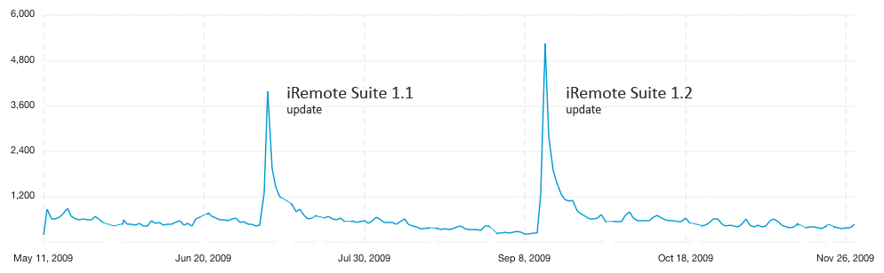
Pic. Combined chart of iRemote Suite sales and updates at AppStore.

Remote PC Suite
Total amount of downloaded Remote PC Suite instances is given below.
Remote PC Suite (PC edition) | 48000
Remote PC Suite (Mac edition) | 6000
Table. Total amount of downloaded Remote PC Suite instances.

Site statistics (based on Google Analytics)
Primary target of iRemote web-site for now is publication of Remote PC Suite. Its infrastructure is not final and provides just single feedback applet (Reviews section). This explains high percentage of new users (81.12%).
Absolute Unique Visitors | 19,762
Visits | 24,203
Pageviews | 74,402
Table. Miscellaneous facts.
Site load corresponds to a number of iRemote Suite instances downloaded from AppStore on daily basis.
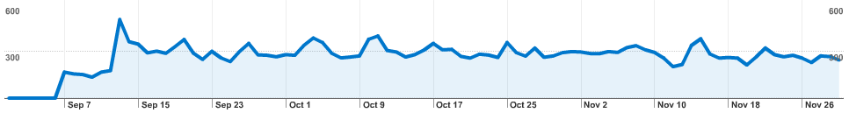
Pic. Web site load.
As it is seen from the chart below, most iRemote users are concentrated in the areas with high level of IT industry. This underlines the fact, that target audience is formed by people familiar with IT. This determines future policies, related to software help and support departments.
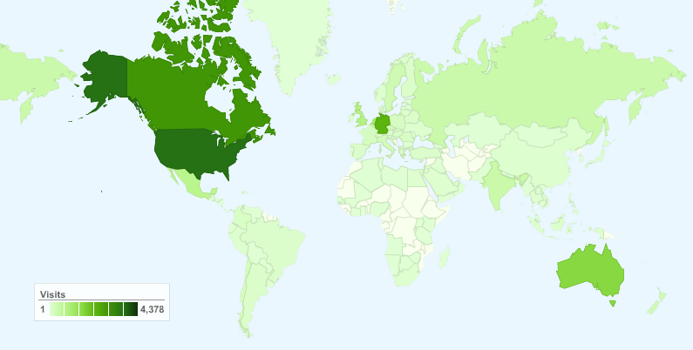
Pic. Distribution of iRemote users around the world.
United States | 18.09%
Canada | 14.10%
Germany | 11.16%
Australia | 8.03%
Netherlands | 5.76%
United Kingdom | 4.41%
Mexico | 3.77%
Singapore | 3.31%
India | 2.26%
Russia | 2.15%
Other | 29.56%
Table. Users’ distribution in details.
OS and browsers statistics just concludes that iRemote support for Windows platform was introduced almost 4 months earlier (in comparison with support for MacOS X). What should be also mentioned is that amount of Linux users in iPhone community is extremely small. Support for this OS should be definitely added with the growth of a number of supported mobile platforms.

Windows | 67.63%
Macintosh | 22.32%
iPhone | 5.24%
iPod | 4.44%
Linux | 0.17%
SymbianOS | 0.02%
SunOS | 0.01%
Table. Browsers.

Internet Explorer / Windows | 27.91%
Firefox / Windows | 25.87%
Safari / Macintosh | 16.19%
Chrome / Windows | 7.97%
Firefox / Macintosh | 5.86%
Safari / iPhone | 5.11%
Safari / iPod | 4.36%
Safari / Windows | 3.38%
Opera / Windows | 2.37%
Opera / Macintosh | 0.15%
Table. Browsers and OS.

Feedback
The most significant sources of feedback were support email, on-site ‘Reviews’ department and iTunes Reviews (in order of intensivity). Users mostly used email and support department on the site to report problems. iTunes reviews mostly contain impressions, and feature requests.
All Feedback content can be derived into three categories:
Feature requests | 40%
Bug reports | 35%
Software marks and reviews | 25%

Business Model
Professional open-source seems to be the most appropriate model for iRemote initiative. The most successful scenario, adopted by followers of such approach, is multi-licensing. Primary goal of such approach is to be able to cover as many segments of market as possible. Market segmentation allows satisfying criteria of different IT industry players.
Above-mentioned scenario is adopted in the way described below. iRemote components (iRemote Suite and Remote PC Suite), developed by iRemote Group, are free and publicly available in both source code and binaries for all target platforms. Project monetization starts on the final phase and includes the following opportunities:
- Custom solutions on top of iRemote. It is impossible to cover all potential areas of iRemote application in a single application. Moreover, the level of details of the same features may differ significantly.
- The most widespread usage scenario of iRemote implies that target host is available directly. This works for accessing desktop within home or office WiFi network. The schema below illustrates such approach.
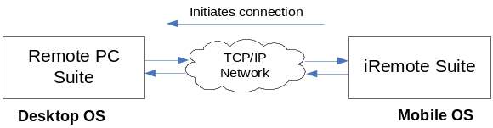
But this does not work for workstations hidden behind proxies or firewalls. In this case it is possible to rich the same target from both mobile device and workstation and communicate through it, even if workstation is not visible directly from mobile device. This services acts as a proxy, wrapping and transmitting iRemote protocol packets.
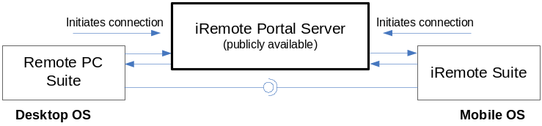
The schema, described above, opens wide perspectives for commercialization. Third party companies are potentially interested in the deployment of such service within their own network or even in public to be able to administer access to it and integrate it with their authentication subsystem.
Most private users are also interested in the use of iRemote platform when being outside of home network. This can be resolved by deploying scalable service and providing individuals and groups with subscriptions.
- Support for public and proprietary remote access/control protocols and services. This is one of the most important directions on the way iRemote integration with enterprise environments. Most organizations runs proprietary IT and security policies. Operating system sometimes plays significant role here. Most desktop OS platforms are supplied with embedded remote control capabilities (like Windows Remote Desktop service). All these things lead to potential need in integration with such services.
- Enterprise services. The most widespread scenarios of application usage may be significantly extended by the development of extra services. Potential areas of such activities are extension of connectivity opportunities (support for multiple networking protocols) and extra levels of security (integration with 3rd-party authentication services and implementation of multiple encryption algorithms).
- Support. Most users from different sectors of IT industry are interested not only in extra features of the software. Lots of customers are often interested in professional, high quality support.
Custom extensions as well as source code of enterprise services are released under proprietary license and are available only for paying parties. Major question is whether to allow users to create commercial applications based on iRemote source code. Potential candidates for Open Source license are GPL and LGPL (or derived).

References
iRemote official web page:
http://www.scientific-soft.com/mobile/apps/iremote/
iRemote Suite iTunes link:
http://itunes.apple.com/WebObjects/MZStore.woa/wa/viewSoftware?id=312222737&mt=8
Take a look inside iRemote for iPhone, MacOS and Windows at:
http://scientific-soft.com/mobile/index.php/menu-iremote/iremote-internals

Project Founder
iRemote project was founded by Egor Pushkin. Egor is mobile/wireless architect and entrepreneur. His specific interests are cross-platform architecture and the development of portable solutions for iPhone, Android, Windows Phone, BlackBerry and variety of desktop platforms.
Egor received his master's degree in Computer Science from Belarusian State University of Informatics and Radioelectronics, Minsk. He majored in applications of neural networks in remote sensing during post-graduate course. Egor lives in Seattle, WA.

Contact Information
Contact project owner for more details on iRemote project:
Egor Pushkin <egor.pushkin@scientiffc-soft.com>

Privacy
Copyright © 2012 Egor Pushkin
Copying or storing of any content for other than personal use is expressly prohibited without prior written permission from the author.

Trademarks
Apple, iPhone and iPhone OS, MacOS and AppStore are trademarks of Apple Inc., registered in the U.S. and other countries.
Windows is a registered trademark of Microsoft Corporation in the United States and other countries.
Android is a trademark of Google Inc. Use of this trademark is subject to Google Permissions.
All other trademarks, trade names, logos and copyrights are the property of their respective holders.

Revision History
Date | Author | Description
12/09/2009 | Egor Pushkin | Initial document version was created.
09/15/2012 | Egor Pushkin | Document was updated.

Contents
iRemote Platform Open Proposal 1
Abstract 2
Introduction 2
Definitions 2
Platform Definition 3
Proposal Target 4
Project Events 4
Project Roadmap 5
iRemote Features and Target Platforms 5
Software Distribution and Security Policies 7
Areas of Adoption 7
Market Analysis 8
Business Model 10
References 12
Project Founder 12
Contact Information 12
Privacy 12
Trademarks 12
Revision History 13
Contents 13

